**Azure Cosmos DB**

Q1: Write an ARM template to deploy all the cosmos DBs

Q2: Integrate the above deployed Azure function with all the cosmos DB and retrieve the logs.

Below screen shots, shows how create Azure cosmos DB.

Go to Azure cosmos DB and click add, then it will take to create Azure cosmos DB as per the below screen shots.

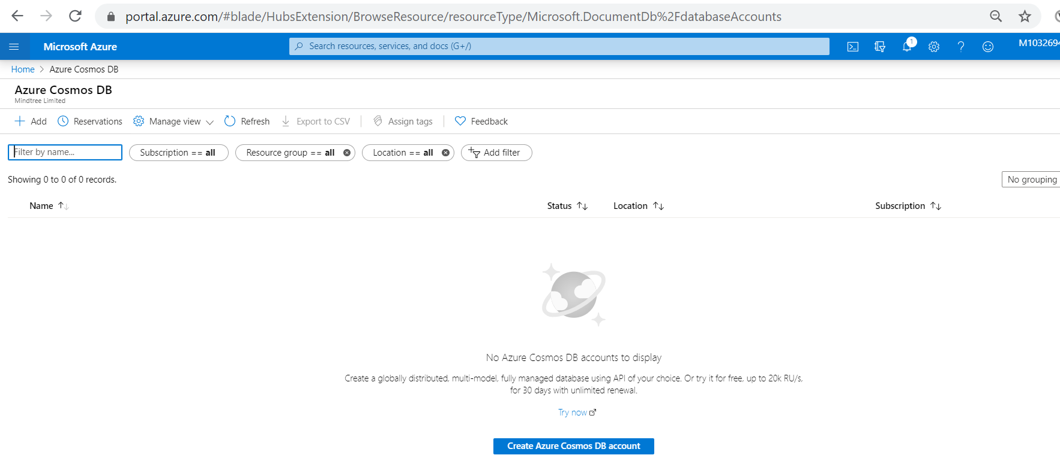

Given the Account Name as “testscosmosdb”.

Select the ResourceGroup as “AzureSKURestrictionsResourceGroup”

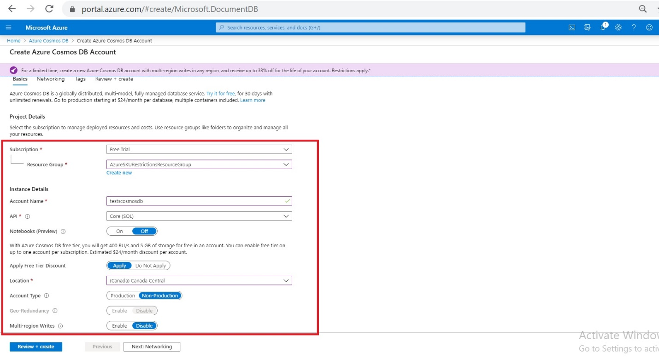

Select **Review + create**. You can skip the **Network** and **Tags** sections.

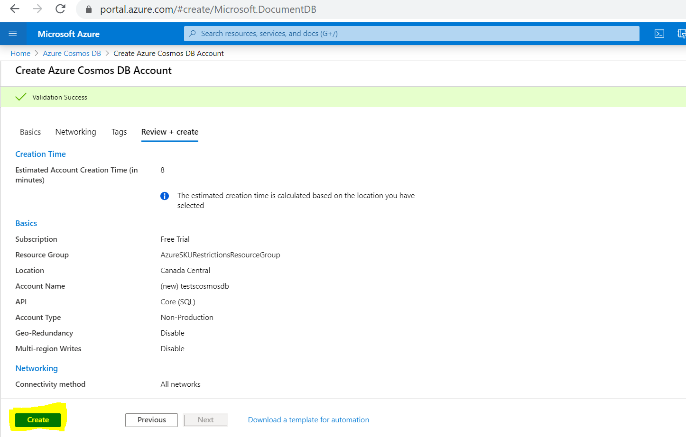

Review the account settings, and then select **Create**. It takes a few minutes to create the account. Wait for the portal page to display **Your deployment is complete**.

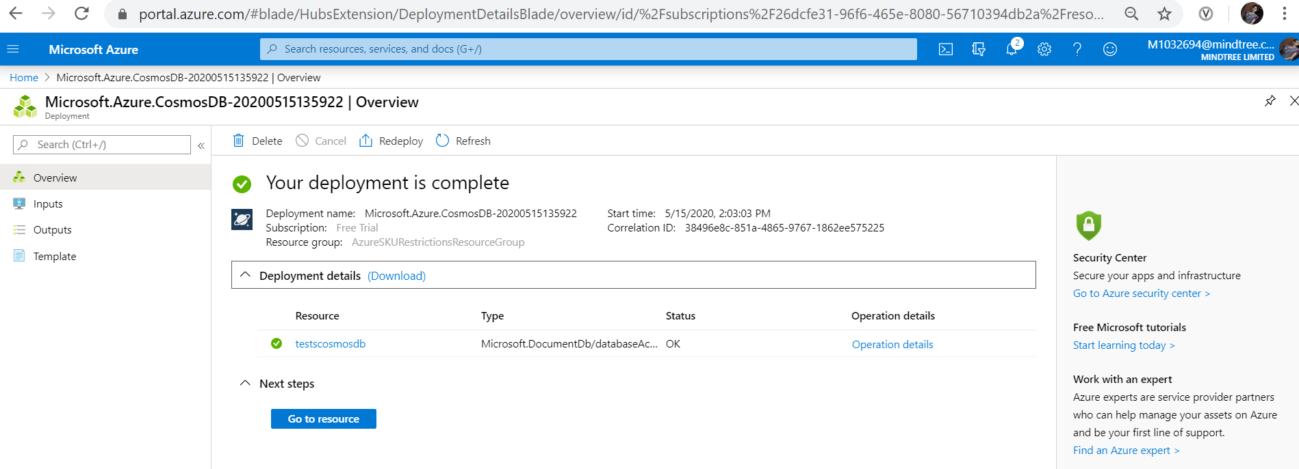

Select **Go to resource** to go to the Azure Cosmos DB account page.

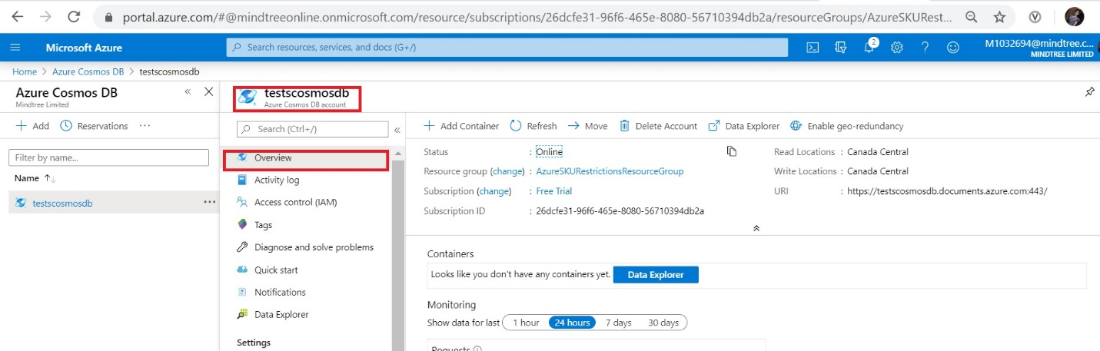

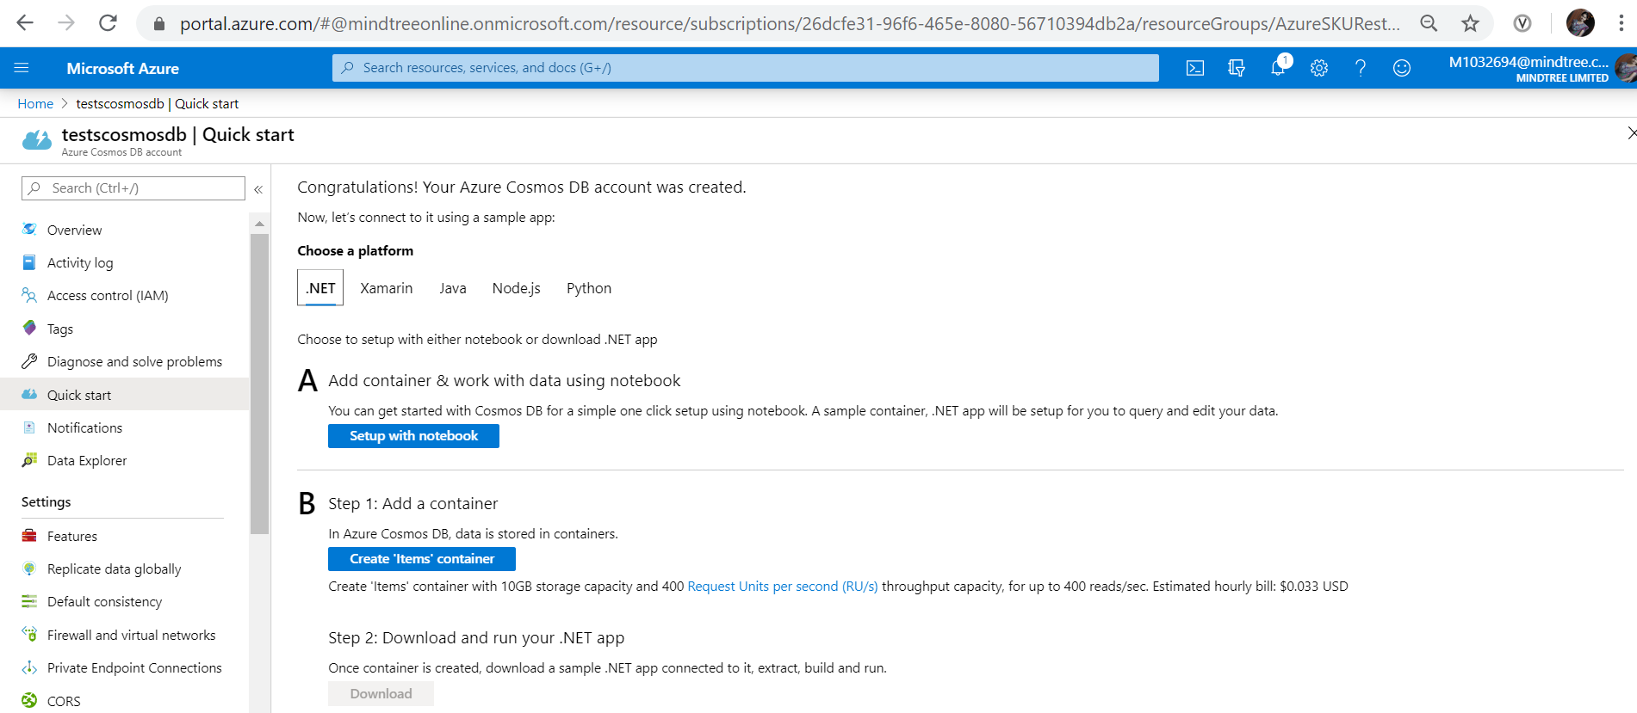

## Add a database and a container

You can use the Data Explorer in the Azure portal to create a database and container.

1. Select **Data Explorer** from the left navigation on your Azure Cosmos DB account page, and then select **New Container**.

You may need to scroll right to see the **Add Container** window.

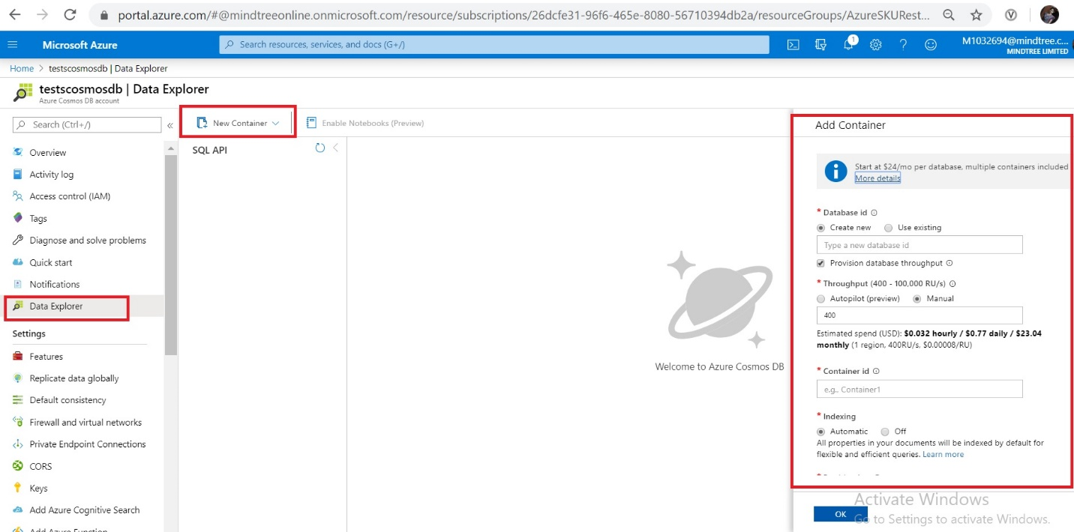

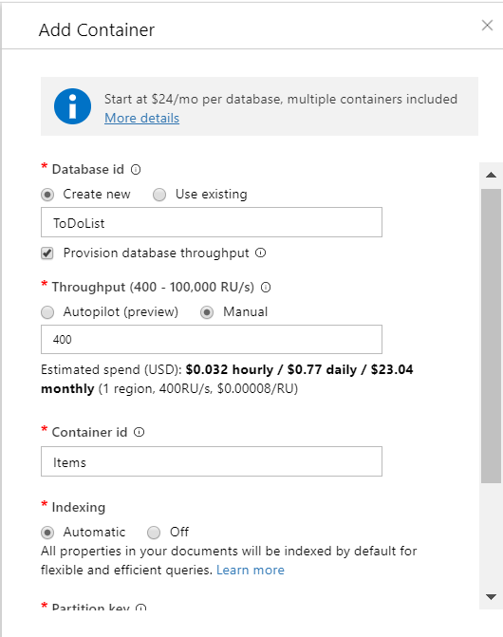

## Add data to your database

Add data to your new database using Data Explorer.

1. In **Data Explorer**, expand the **ToDoList** database, and expand the **Items** container. Next, select **Items**, and then select **New Item**.

## 

## Add the following structure to the document on the right side of the Documents pane:

## 

1. Select **Save**.

## 

## 

## Azure Functions has the ability to integrate easily with a number of other Azure products—and Cosmos DB is one of them.

## 

## click on New Output, which will display a list of icons. Scroll down to the one called Azure Cosmos DB, select it and then further down on the page you’ll see a SELECT button. You know what to do. (Click that button!)

## 

## Run the TimerTrigger1 function and get the logs as shown below.

## 